Manual Obfuscation
I employed a technique called lexical obfuscation, which included the following: Renaming variables renaming functions, applying readability formatting removal. The target is to make the code more difficult for a human to interpret while preserving the same functionality.

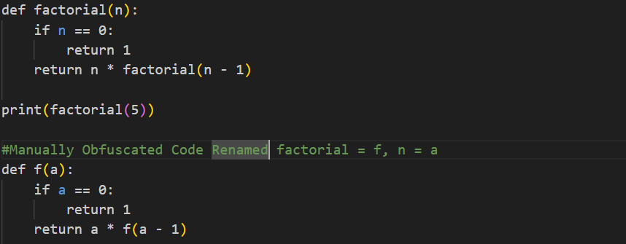

Automatic Obfuscation
I used the PyObfusinator tool to my Python code and it obfuscated the code automatically. The tool adds multiple layers of obfuscation such as byte-string encoding, using exec() for structural wrapping, removal of readable identifiers on the lexical level, and control-flow transformations with bitwise operations and modular arithmetic. In this way, the code is very complex to read or reverse-engineer, but at the same time, the original behavior is still retained.

